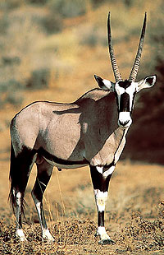

**GEMSBOK**

**PHYSIOLOGY:**

* HEIGHT/WEIGHT**:** Male – 1.25m/227kg Female – 1.2m/215kg
* long, straight horns with rings on lower end; both male and female have horns
* thick neck and short mane; black, horse-like tail
* grey in color with distinctive black and white markings on face, legs and belly
* average maximum lifespan of 20 years

**DIET:**

* primarily a grazer eating dry desert grasses; will browse and dig for roots
* will drink water, if available, but can survive for weeks without water
* feed early in the morning, late afternoons and on moon-lit nights when water content of grass is best
* have also been known to eat wild melons for water

**HABITAT:**

* arid and semi-arid grasslands; light open woodlands; desert and semi-desert
* native to eastern and south-western continental Africa; introduced to South Africa

**HABITS:**

* form herds of up to 40 animals; can number in hundreds in rainy season
* bachelor herds are rare
* dominant male is very territorial; only breeders are dominant males
* excellent sense of sight, hearing and smell
* very fast runner
* not afraid of large predators; defend themselves by lowering horns parallel to ground and skewering threats
* tight circle formed when group threatened by hyenas – especially when calves present
* 9 months gestation; breed year round with majority born in August & September; single calves

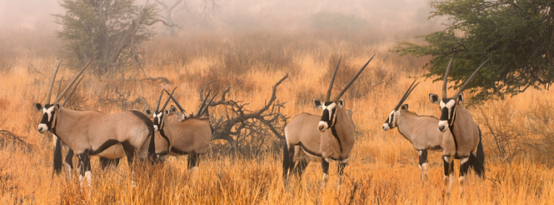

Bibliography:

en.wikipedia.org/wiki/**Gemsbok**

[www.cruisersafaris.com/animals/**gemsbok**.htm](http://www.cruisersafaris.com/animals/gemsbok.htm)

[www.wild-about-you.com/Game**Gemsbok**.htm](http://www.wild-about-you.com/GameGemsbok.htm)

Photos:

flickr

shutterstock